Multithreading Programming in Python
What is Thread?
In computing, a process is an instance of a computer program that is being executed. Any process has 3 basic components:
- An executable program.
- The associated data needed by the program (variables, work space, buffers, etc.)
- The execution context of the program (State of process)
A thread is an entity within a process that can be scheduled for execution. Also, it is the smallest unit of processing that can be performed in an OS (Operating System).
Running several threads is similar to running several different programs concurrently, but with the following benefits −
Multiple threads within a process share the same data space with the main thread and can therefore share information or communicate with each other more easily than if they were separate processes.
Threads sometimes called light-weight processes and they do not require much memory overhead; they are cheaper than processes.
A thread has a beginning, an execution sequence, and a conclusion. It has an instruction pointer that keeps track of where within its context it is currently running.
It can be pre-empted (interrupted)
It can temporarily be put on hold (also known as sleeping) while other threads are running - this is called yielding.

The Threading Module
The newer threading module provides much more powerful, high-level support for threads than the thread module discussed in the previous section.
The threading module exposes all the methods of the thread module and provides some additional methods −
- threading.activeCount() − Returns the number of thread objects that are active.
- threading.currentThread() − Returns the number of thread objects in the caller's thread control.
- threading.enumerate() − Returns a list of all thread objects that are currently active.
In addition to the methods, the threading module has the Thread class that implements threading. The methods provided by the Thread class are as follows −
- run() − The run() method is the entry point for a thread.
- start() − The start() method starts a thread by calling the run method.
- join([time]) − The join() waits for threads to terminate.
- isAlive() − The isAlive() method checks whether a thread is still executing.
- getName() − The getName() method returns the name of a thread.
- setName() − The setName() method sets the name of a thread.

Creating Thread using Thread Module
- Import threading module by writing -> import threading
- To create a new thread, we create an object of Thread class. It takes following arguments:
  - target: the function to be executed by thread
  - args: the arguments to be passed to the target function
- To start a thread, we use start method of Thread class.
- Once the threads start, the current program (you can think of it like a main thread) also keeps on executing. In order to stop execution of current program until a thread is complete, we use join method.
- As a result, the current program will first wait for the completion of t1 and then t2. Once, they are finished, the remaining statements of current program are executed.

Example
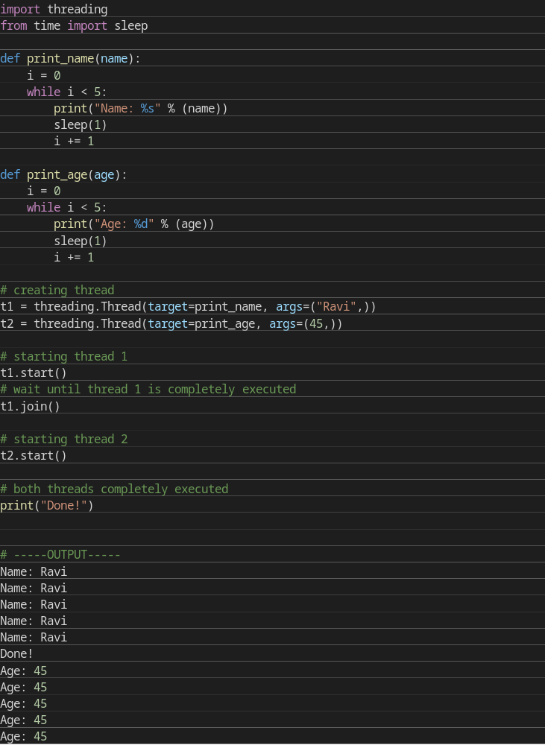
Example 2

